NOSQL DATABASE

1.1 BACKGROUND
Traditional relational databases have been widely used to store and manage structured data in tables, rows, and columns. (Hulsebos et al., 2021)
Although relational databases such as MySQL offer strong consistency and reliable transaction processing, modern applications often produce large volumes of diverse, rapidly changing data that require more flexible storage solutions. (Relational Database vs NoSQL, 2026)
NoSQL databases were developed to address these challenges by offering scalable and schema-flexible data storage solutions. (Bhosale, 2022) Unlike relational databases, NoSQL systems can store data as documents, key-value pairs, graphs, or column-family structures without a fixed schema. (Corporation, 2024)

1.2 OBJECTIVE
This portfolio explores NoSQL database concepts through the Kudi Trust Bank case study. It demonstrates document-oriented database modelling, MongoDB collections and documents, CRUD operations, aggregation techniques, and evaluates the advantages and limitations of NoSQL databases in contemporary banking environments.

2. OVERVIEW OF NOSQL DATABASE
NoSQL (Not Only SQL) refers to a category of databases engineered to support large-scale data storage and flexible data structures. These systems are specifically optimized for scalability, high performance, and the efficient management of unstructured or semi-structured data.
Common NoSQL database types include:
Database Type | Description | Example
Document Database | Stores data in JSON-like documents | MongoDB
Key-Value Database | Stores data as key-value pairs | Redis
Column-Family Database | Stores data in columns rather than rows | Cassandra
Graph Database | Stores relationships between entities | Neo4j

MongoDB is a commonly used document-oriented database and will be used in this portfolio.

3. RELATIONAL DATABASES VS NOSQL DATABASES
Feature | MySQL (Relational Database) | MongoDB (NoSQL Database)
Structure | Tables | Collections
Records | Rows | Documents
Schema | Fixed Schema | Flexible Schema
Relationships | Primary and Foreign Keys | Embedded Documents
Query Language | SQL | MongoDB Query Language
Scalability | Vertical Scaling | Horizontal Scaling
Data Storage | Structured Data | Semi-Structured Data

Kudi Trust Bank uses a relational database structure with Customers, Accounts, and Transactions tables. This configuration suits financial transactions well because it provides strong consistency and data integrity.
MongoDB offers greater flexibility by letting you store related information in a single document. This can improve performance for certain applications such as customer activity tracking, mobile banking logs, and fraud analysis.

4. NOSQL DATA MODELLING FOR KUDI TRUST BANK
Unlike MySQL, which organizes information across multiple related tables, MongoDB stores data as documents within collections.

4.1 CUSTOMER DOCUMENT
The following document represents a customer record in MongoDB.
JSON
{
"customer_id": 1,
"first_name": "Nathan",
"last_name": "Smith",
"email": "natsmith@kudi.com",
"phone": "08012345678"
}
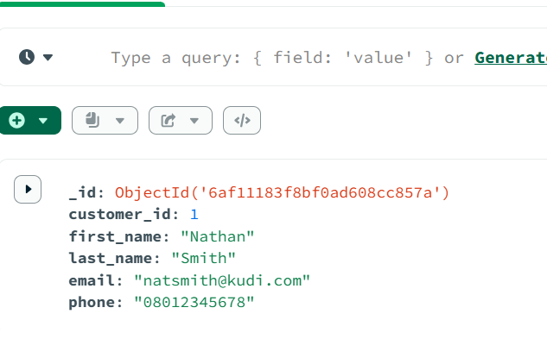
Customer information is stored in a single JSON structure. Each document in the collection may include different fields as necessary.

4.2 CUSTOMER AND ACCOUNT DOCUMENT
JSON
{
"customer_id": 1,
"first_name": "Nathan",
"last_name": "Smith",
"accounts": [
{
"account_number": "0123456789",
"account_type": "Savings",
"balance": 50000,
"status": "ACTIVE"
}
]
}

Embedded documents store account information within the customer record, reducing the need for JOIN operations common in relational database systems.

4.3 CUSTOMER, ACCOUNT AND TRANSACTION DOCUMENT
JSON
{
"customer_id": 1,
"accounts": [
{
"account_number": "0123456789",
"transactions": [
{
"reference": "KUDI-TXN-001",
"type": "DEPOSIT",
"amount": 1000,
"status": "COMPLETED"
}
]
}
]
}
MongoDB supports hierarchical storage of related data within a single document. Customer, account, and transaction information are accessible together, eliminating the need for complex joins.

5. MONGODB DATABASE STRUCTURE
For this portfolio, a MongoDB database named Kudi_Trust_Bank_nosql was created. Within the database, three collections were established to store banking data:
Kudi_Trust_Bank_nosql
- Customers
- Accounts
- Transactions
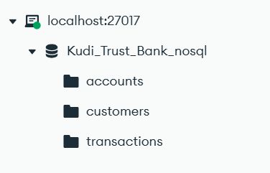
The database structure mirrors the existing MySQL implementation used in previous portfolios and shows how to represent equivalent information in a NoSQL environment.

6. CRUD OPERATIONS IN MONGODB
CRUD operations represent the fundamental actions performed on data:
Operation | Meaning
Create | Insert new documents
Read | Retrieve documents
Update | Modify existing documents
Delete | Remove documents

Each operation will be demonstrated using MongoDB Compass and MongoDB commands.

6.1 CREATE OPERATION
The create operation was performed using the insertOne() command. This demonstrates how MangoDB stores data as documents instead of rows within tables.
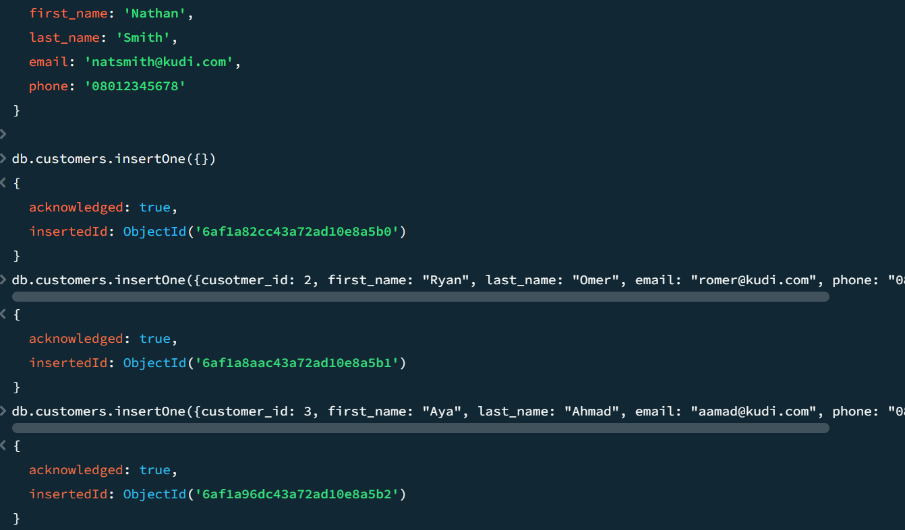

6.2 READ OPERATION
The read operation used the MongoDB find() method to retrieve customer information. The query returned the document associated with customer_id 1.
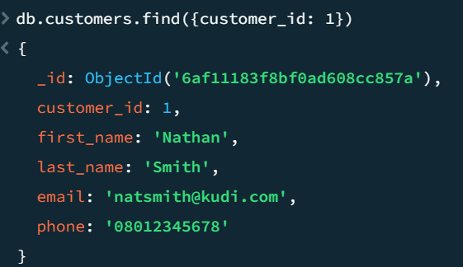

6.3 UPDATE OPERATION
The update operation modified the phone number stored in an existing customer document by using the $set operator.
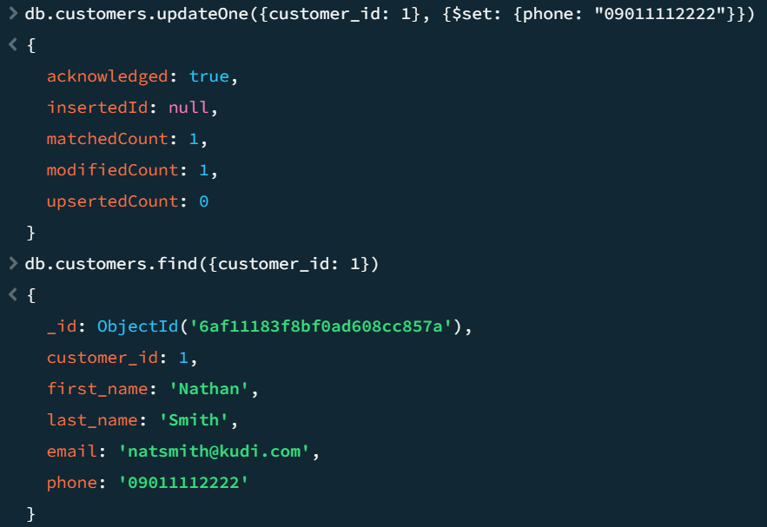

6.4 DELETE OPERATION
The delete operation removed the document associated with customer ID 3 from the collection
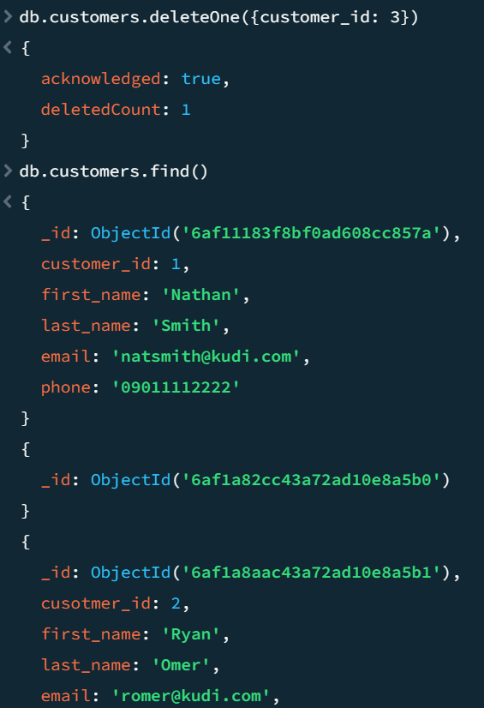

7. AGGREGATION FRAMEWORK IN MONGODB
Aggregation in MongoDB enables you to process and analyze data stored in collections. It supports operations analogous to SQL aggregate functions, including SUM(), COUNT(), AVG(), MIN(), and MAX().
The aggregation framework efficiently groups, filters, transforms, and summarizes large datasets.

Calculating Total Customer Funds
JAVASCRIPT
db.accounts.aggregate([
{
$group: {
_id: null,
totalFunds: { $sum: "$balance" }
}
}
])
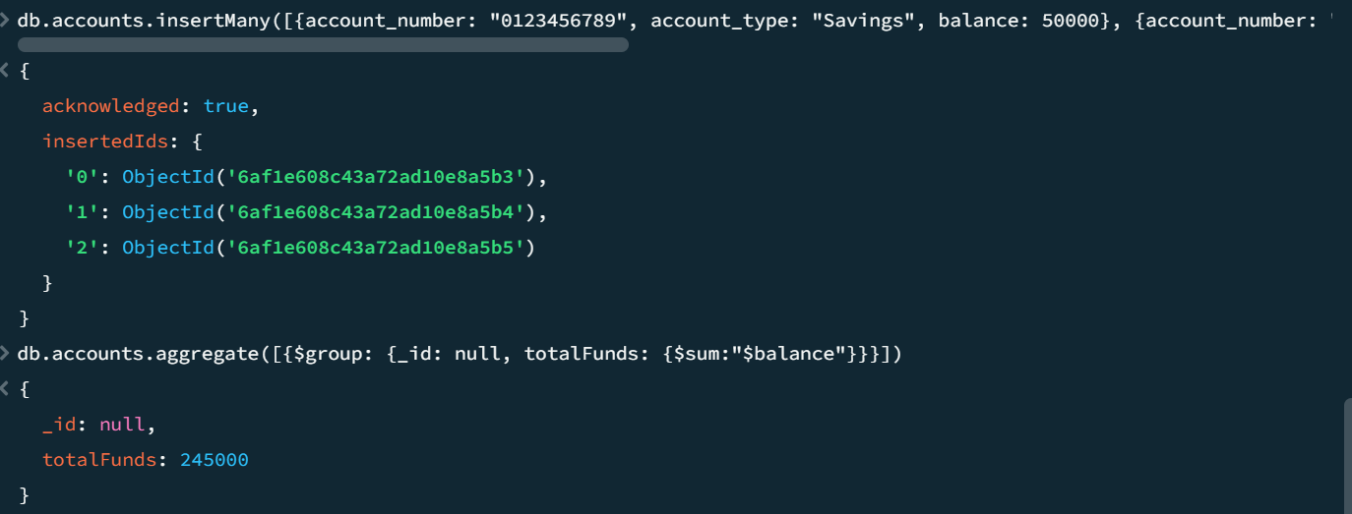
This aggregation operation calculates the total balance held by all customers in the Kudi Trust Bank database. Similar functionality would be achieved in MySQL using the SUM() function.

Counting Accounts by Type
JAVASCRIPT
db.accounts.aggregate([
{
$group: {
_id: "$account_type",
totalAccounts: { $sum: 1 }
}
}
])
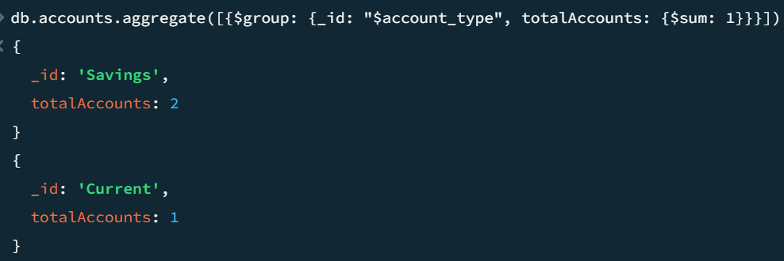
This aggregation groups account records according to account type and returns the number of accounts within each category.

8. ADVANTAGES OF NOSQL DATABASES
NoSQL databases provide several advantages that make them suitable for modern large-scale applications.
Advantage | Benefit to Kudi Trust Bank
Scalability | Supports rapid growth in customer data and transactions
Flexibility | New fields can be added without modifying the entire schema
Performance | Fast retrieval of document-based data
High Availability | Supports distributed deployment across multiple servers
Big Data Support | Handles large volumes of customer activity and transaction logs

As Kudi Trust Bank expands its digital banking services, a NoSQL database efficiently manages large volumes of customer activity data, mobile application interactions, ATM logs, and analytical information. This adaptability facilitates future growth while ensuring consistent system performance.

9. LIMITATIONS OF NOSQL DATABASES
Although NoSQL databases offer numerous advantages, they also present some limitations.
Limitation | Impact
Reduced Transaction Support | Traditional relational databases provide stronger support for complex financial transactions
Data Duplication | Similar data may be stored in multiple documents
Lack of Joins | Relationships must often be handled differently
Validation Challenges | Flexible schemas require additional controls
Reporting Complexity | Complex business reports may be easier to generate using SQL databases

Relational databases are preferred for core banking operations, including transfers, deposits, withdrawals, and balance management, due to their advanced transaction management and robust ACID compliance.

10. APPLICATIONS OF NOSQL IN KUDI TRUST BANK
NoSQL databases can complement Kudi Trust Bank's existing relational database infrastructure.

10.1 Mobile Banking Activity Tracking
Customer interactions with mobile banking applications generate substantial volumes of semi-structured data. MongoDB can efficiently store and retrieve this information.

10.2 ATM Transaction Logs
ATM systems continuously generate event records, which can be archived and analyzed using a NoSQL database.

10.3 Customer Behaviour Analytics
MongoDB can store customer activity histories, helping identify usage patterns and support improvements in service delivery.

10.4 Fraud Detection
Large datasets collected from customer activities may be analyzed to detect anomalous behavior and identify potential fraudulent activities.

10.5 Audit and Monitoring Systems
NoSQL databases support system monitoring, log management, and operational analytics within banking infrastructure.

11. DISCUSSION
The examination of NoSQL databases illustrates how contemporary organizations manage increasingly large and diverse datasets. Unlike relational databases, which prioritize structured data and rigid schemas, MongoDB offers flexibility through document-oriented storage and dynamic schemas.
For Kudi Trust Bank, relational databases such as MySQL are essential for mission-critical financial transactions because they robustly support ACID properties and transaction integrity. In addition, MongoDB can store semi-structured information, process large volumes of activity data, and support analytical workloads.
Integrating relational and NoSQL technologies allows organizations to capitalize on the strengths of both approaches. MySQL ensures precise transaction processing, whereas MongoDB delivers scalability and flexibility to address evolving business requirements. Financial institutions increasingly use this hybrid strategy to balance reliability, performance, and innovation.

12. CONCLUSION
This portfolio examined the concepts and practical applications of NoSQL databases, focusing on MongoDB and the Kudi Trust Bank case study. Document-oriented data modeling was illustrated through customer, account, and transaction documents, emphasizing the flexibility of NoSQL data storage. The portfolio presented CRUD operations and aggregation techniques as essential mechanisms for data management and analysis.
The portfolio also assessed the advantages and limitations of NoSQL databases and analyzed their potential applications in the banking sector. Although relational databases remain essential for transaction processing, NoSQL databases strongly support analytics, customer activity tracking, and large-scale data management. Collectively, these technologies form a robust foundation for contemporary banking systems.

REFERENCES

Hulsebos, M., Demiralp, Ç. & Groth, P. (2021). GitTables: A Large-Scale Corpus of Relational Tables. Proceedings of the ACM on Management of Data 1(1):1-17. https://doi.org/10.1145/3588710

(2026). Relational Database vs NoSQL. GeeksforGeeks. https://www.geeksforgeeks.org/dbms/difference-between-relational-database-and-nosql/

Bhosale, P. (2022). NoSQL Databases Explored: A Comprehensive Study of Columnar, Graph, and Document-Based Approaches. N. American. J. of Engg. Research 3(4). https://najer.org/najer/article/view/105

Corporation, O. (2024). Schema Flexibility in Oracle NoSQL Database. Oracle NoSQL Database Documentation. https://docs.oracle.com/en/database/other-databases/nosql-database/25.3/nsdev/schema-flexibility-oracle-nosql-database.html

